Automatic Sugarcane Bud Cutter Machine | Variable Cutting Size

Sugarcane is one of the most widely farmed crop over the globe. After harvesting sugarcane, cutting the sugarcane into chunks is a very time consuming process. All sugarcane cutting machines are either manual or semi automatic. This involves a lot of time and labor for each machine since the operation is not fully automatic.
So here we propose a fully automatic sugarcane bud cutter that utilizes pneumatic power for automatic sugarcane cutting mechanism. The system makes use of a mini tabletop machine with a powerful motorized arrangement to push an entire sugarcane bud into the machine cutter. Once a sugarcane stick.bud is inserted a rubber gripper roller powered by geared motor is used to drive the stick towards the cutter at a specific rate.
A second roller is attached to the system through a screw based arrangement is used to push the sugarcane stick towards the other roller and maintain a grip over the cane. The system is further integrated with a pneumatic cylinder. A cutter blade is attached to the front end of the actuator. The pneumatic cylinder is powered by an external compressor to drive it back and forth using high air pressure.
This blade is used to cut the sugarcane bud into equal pieces in coordination with the feeder rollers. The machine uses rollers to pull in the sugarcane stick and cutter to cut it. Now the system also includes a controller circuitry that controls the cutting length of each piece. This allows the operator to cut the sugarcane in desired pieces.

Components:
- Pneumatic Cylinder
- Pneumatic Piping
- Pipe Joints and Fittings
- Valves
- Cutter Blade
- High Torque Motor
- Shaft
- Couplings
- Rubber Rollers
- Bearings
- Base Frame
- Supporting Frame
- Mounts and Joints
- Screws and Nuts

Advantages:

- Single Operator Machine
- Automatic Operation
- Variable Size Cutting
- Accurate Cutting

Disadvantages:

- Requires Air Supply
- Blade needs to be replaced/sharpened from time to time

Block Diagram:

Front View

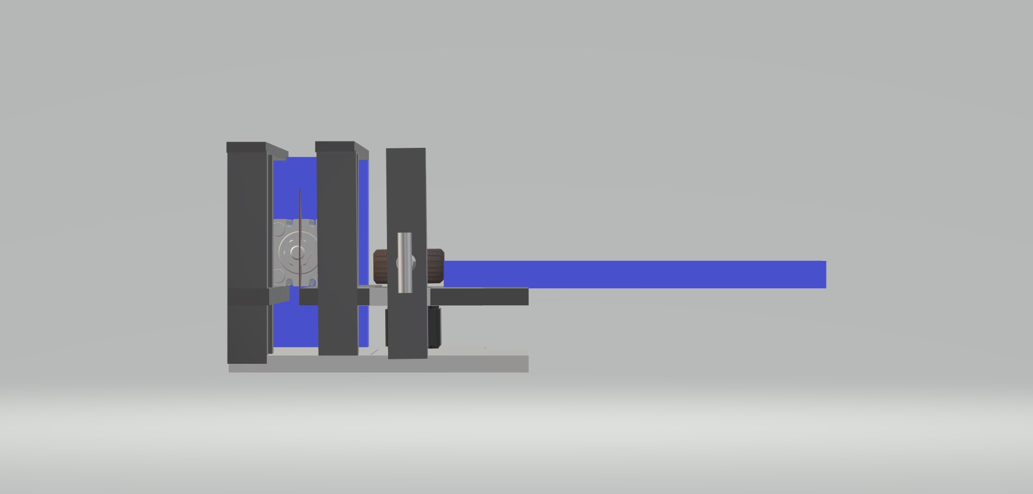

Side View
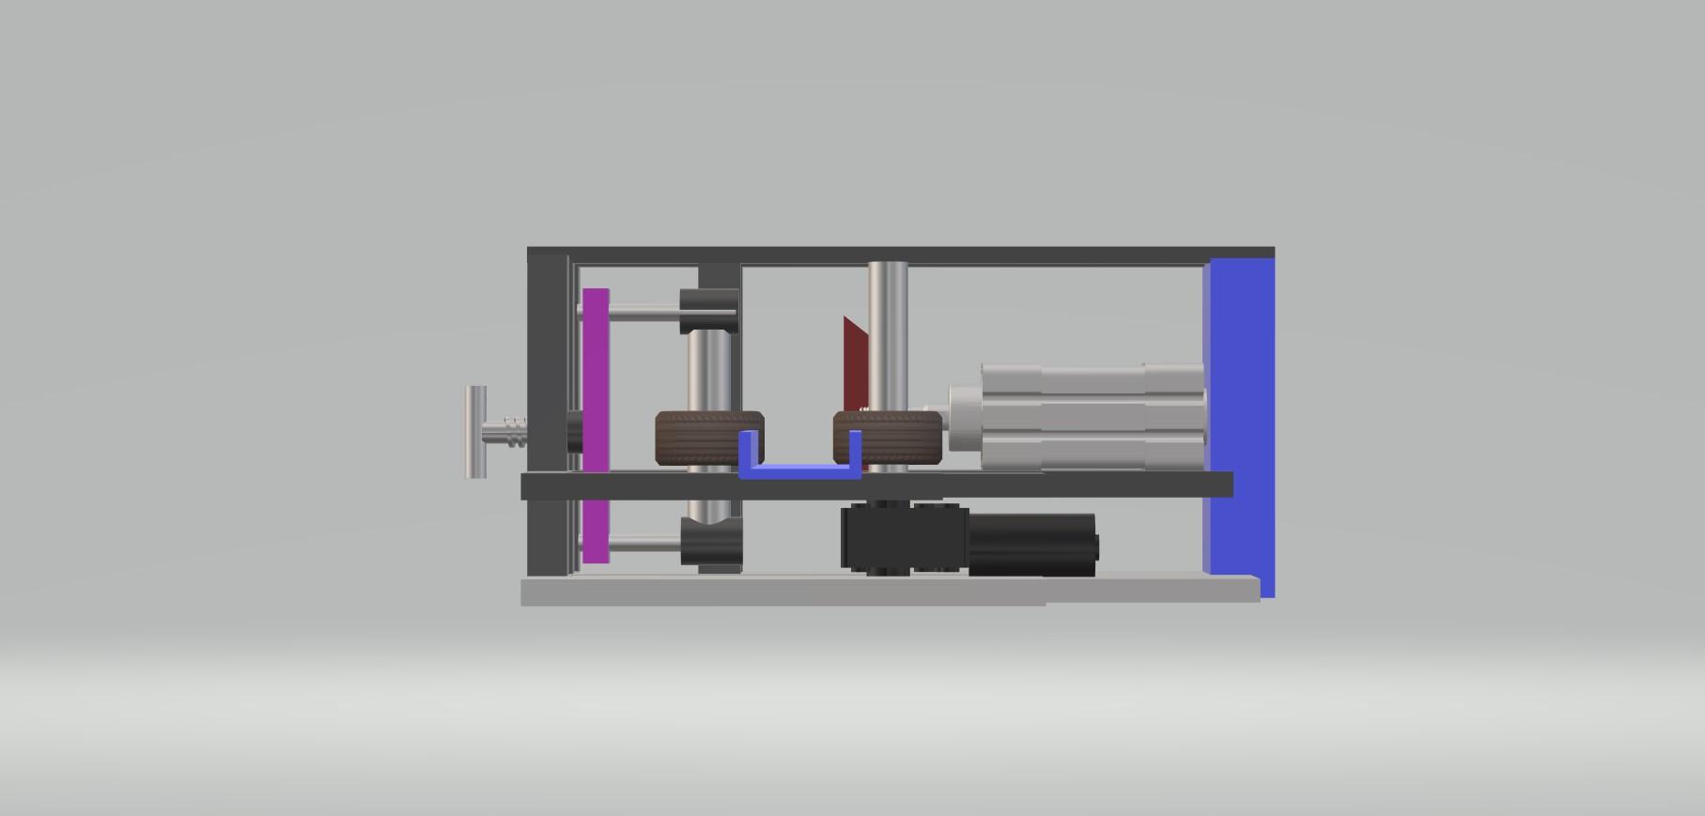

3d Views
